硬件安全需求 HW Safety Requirements Specification
 | 文件编号 / Document ID | SGS -FS-HW-xx
 | 密级 / Confidentiality
项目名 / Project Name
项目编号 / Project ID
编制 / Author
审核 / Reviewer
批准 / Approver
日期 / Date
版本 / Version
发布范围 / Distribution list

注意 / Notice:
- 本文档的目的是帮助作者制作满足ISO26262相关要求的工作产品
This document is aimed to assist the author to develop work products in compliance with the corresponding requirements in ISO26262.
- 通过本模板所创建的工作产品不能认为其一定会自动满足ISO26262的要求
The work products generated via this template cannot be treated as are in compliance with requirements of ISO26262 automatically.
- 本文档内容仅供参考
The content of this document is for reference only
- 如有问题，请和我们联系：chad.huang@sgs.com
please contact with us via chad.huang@sgs.com if any question.
- 此模板知识产权归通标标准技术服务（上海）有限公司所有，仅限该咨询项目使用。未经书面许可，禁止打印、复印、转发

模板变更履历 / Template Change History
版本  Version | 状态  Status | 编制人  Author | 编制日期  Date | 批准人  Approver | 批准日期  Approve Date | 内容描述  Description

HSR变更履历 / HSR Change History
版本  Version | 状态  Status | 编制人  Author | 编制日期  Date | 批准人  Approver | 批准日期  Approve Date | 内容描述  Description

目录 / Table of Contents
1 概要说明 / General Information 5
1.1 文档目的 / Document Purpose 5
1.2 输入文档 / Input Document 5
1.3 参考文档 / Reference Document 5
1.4 术语和缩略语 / Terms and Abbreviation 5
2 硬件功能分析 6
2.1 硬件框图 6
2.2 硬件功能 6
3 硬件功能需求 6
3.1 电源模块/Power Supply 6
3.1.1 电源模块初步架构 / Power supply relative Architecture 6
3.1.2 硬件需求 / Hardware requirement description 6
3.2 数字输入 / Digital Inputs 7
3.2.1 数字输入模块初步架构 / Digital Inputs relative Architecture 7
3.2.2 硬件需求 / Hardware requirement description 7
3.3 高边输出 / HSD Output 7
3.3.1 高边输出模块初步架构 / HSD output relative Architecture 7
3.3.2 硬件需求 / Hardware requirement description 8
3.4 MCU 模块 / MCU Module 8
3.4.1 MCU模块初步架构 / MCU module relative Architecture 8
3.4.2 硬件需求 / Hardware requirement description 8
4 非功能需求规范 / Non-Functional Requirements Specification 8
5 生产、运行、服务和报废相关的需求 / Requirements Specification for production, operation, service and decommissioning 9

概要说明 / General Information

文档目的 / Document Purpose
硬件安全需求用于定义系统安全需求在硬件层级的实现，结合系统功能需求指导硬件架构设计和详细设计。

输入文档 / Input Document
本节描述“系统需求规范”的输入文档，包括但不限于：硬件组件评估的相关流程，相关的安全需求，相关器件的数据手册, 硬件组件评估计划等

序号  No. | 文档名称  Document Name | 文档版本  Version | 文档日期  Date
1 | 系统（安全）需求 / Technical safety concept
2 | 系统架构
3 | HSI
4

参考文档 / Reference Document
序号  No. | 文档名称  Document Name | 文档版本  Version | 文档日期  Date
1 | ISO26262-5:2018

术语和缩略语 / Terms and Abbreviation
术语/缩略语  Terms and Abbreviation | 描述  Description
PCB | printed circuit board
MCU | Microcontroller Unit
EMC | electromagnetic compatibility
CAN | Controller Area Network
LIN | Local Interconnect Network
HSD | High Side
LSD | Low Side
LDO | Low Drop voltage Output
SMPS | Switch Mode Power Supply

硬件功能分析

硬件框图
硬件框图需要体现基本的硬件功能模块，对详细的信号可以初略体现。此图不作为需求，仅作为信息。
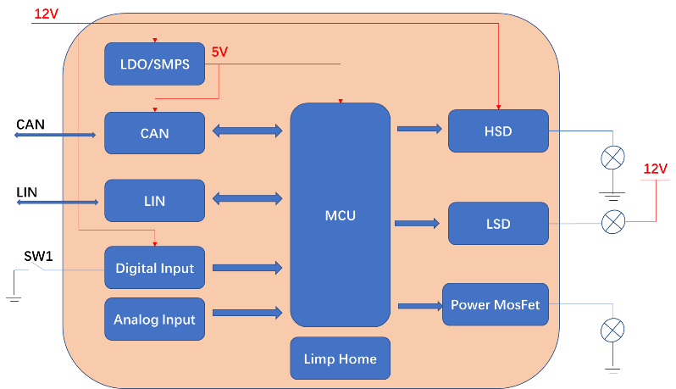

硬件功能
根据系统需求定义及系统架构定义，硬件设计需要有12V电源模块、CAN通信模块、LIN通信模块、数字输入信号采集、模拟信号采集、MCU模块、HSD输出、LSD输出、Power MOSFET模块以及LIMP HOME模块。 各个模块的详细设计需参考功能需求定义和非功能需求定义。

硬件功能需求

电源模块/Power Supply

电源模块初步架构 / Power supply relative Architecture
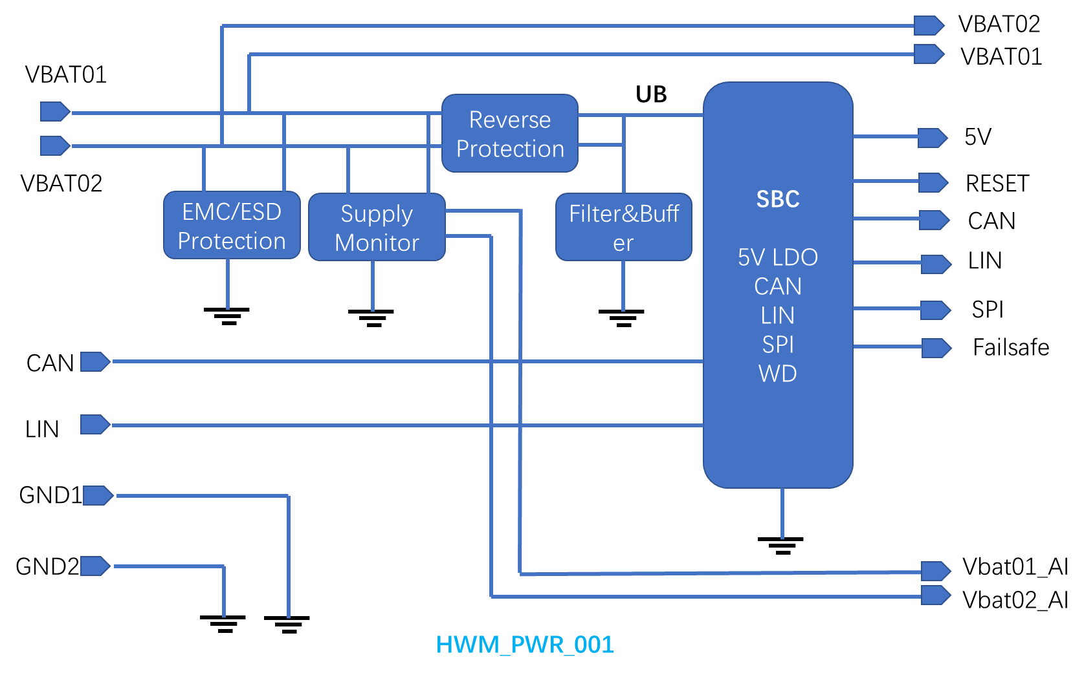

硬件需求 / Hardware requirement description

Req-ID | 需求描述 | 类型  Type | 来源 | ASIL | 可验证性 |  | 验证准则  Criteria | 变量  Variant | 分配到硬件架构 | 发布阶段  Release | 状态  Status | 备注  Comments
 |  |  |  |  | 可/否 | 验证活动
HWR_PWR_001 | There shall have two separate power supply inputs for the whole ECU. VBAT01 and VBAT02. Current capability of each shall not less than 10A. | Requirement / Comments | SYR_001 | ASIL A(B) | YES | EET | 1, two power supply inputs;  2, no failure when current is not higher than 10A; | E6 | HWM_PWR_001 | HW Release 0100 | working
HWR_ PWR_002 | VBAT01 and VBAT02 provide power supply to SBC parallel, current capability input to SBC for each shall not less than 1A. | Requirement | SYR_001 | ASIL A(B) | YES | EET | 1, VBAT01, VBAT02 connect to SBC input;  2, no failure when each input current is not higher than 1A; | E7 | HWM_PWR_001 | HW Release 0100 | working
HWR_PWR_016 | For ASIL C, ASIL C(D) circuits, the RHFT of power supply module shall smaller than 15FIT. The SPFM shall higher than 97%, LFM shall higher than 80%. | Requirement | SYR_001 | ASIL C | YES | FMEDA, PMHF |  | E6  E7  E8 | HWM_PWR_001 | HW Release 0100 | working

数字输入 / Digital Inputs

数字输入模块初步架构 / Digital Inputs relative Architecture
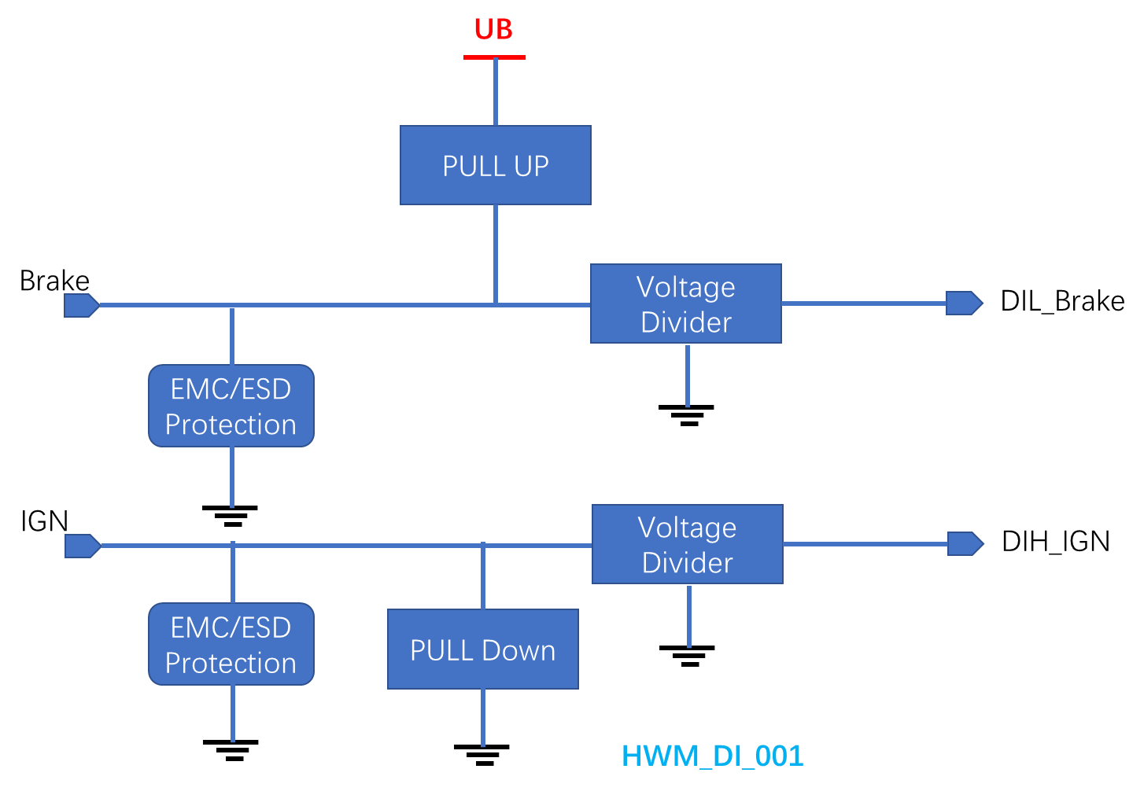

硬件需求 / Hardware requirement description
Req-ID | 需求描述 | 类型  Type | 来源 | ASIL | 可验证性 |  | 验证准则  Criteria | 变量  Variant | 分配到硬件架构 | 发布阶段  Release | 状态  Status | 备注  Comments
 |  |  |  |  | 可/否 | 验证活动
HWR_DI_001 | A low active digital input circuit shall design for brake switch status detection. | Requirement / Comments | SYR_002 | ASIL A(B) | YES | EET | HWR_DI_001 | E6 | HWM_DI_001 | HW Release 0100 | working | SYR_002

高边输出 / HSD Output

高边输出模块初步架构 / HSD output relative Architecture
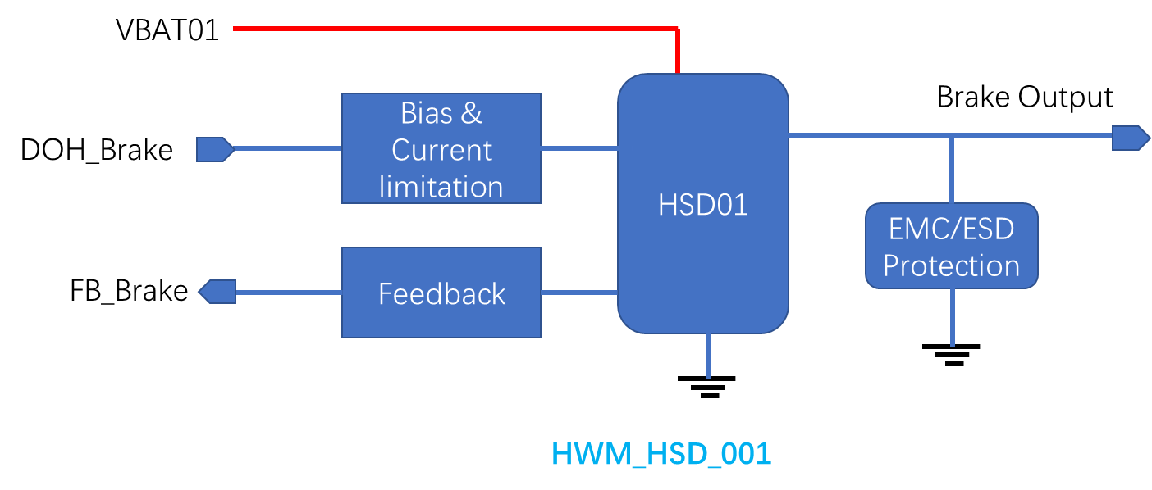

硬件需求 / Hardware requirement description
Req-ID | 需求描述 | 类型  Type | 来源 | ASIL | 可验证性 |  | 验证准则  Criteria | 变量  Variant | 分配到硬件架构 | 发布阶段  Release | 状态  Status | 备注  Comments
 |  |  |  |  | 可/否 | 验证活动
HWR_HSD_001 | An HSD circuit shall design for the output control of brake light. | Requirement / Comments | SYR_003 | ASIL A(B) | YES | EET | Output voltage higher than Vbat-1V. | E6 | HWM_PWR_001 | HW Release 0100 | working

MCU 模块 / MCU Module

MCU模块初步架构 / MCU module relative Architecture
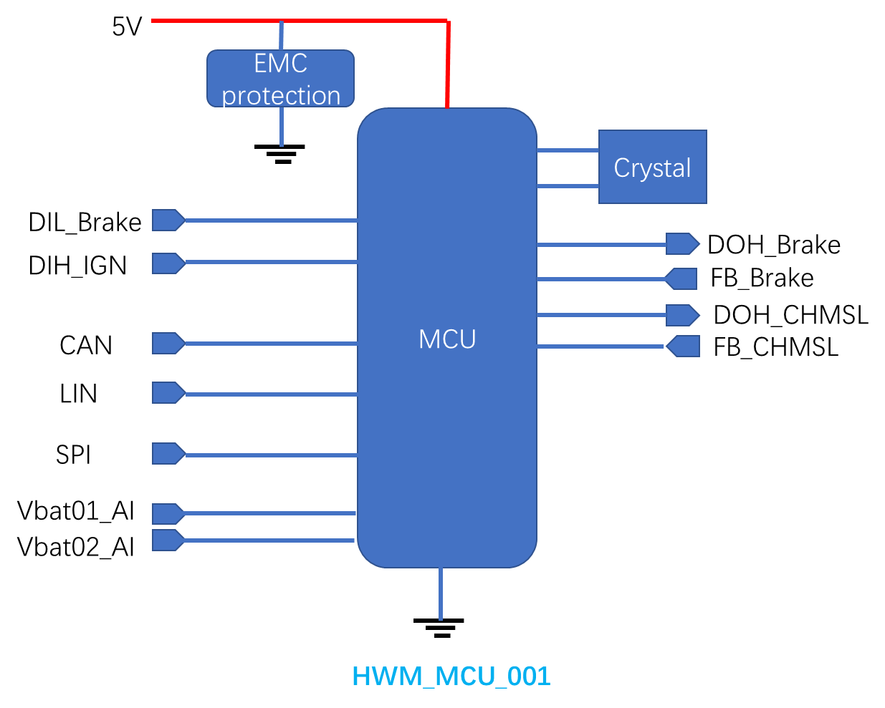

硬件需求 / Hardware requirement description
Req-ID | 需求描述 | 类型  Type | 来源 | ASIL | 可验证性 |  | 验证准则  Criteria | 变量  Variant | 分配到硬件架构 | 发布阶段  Release | 状态  Status | 备注  Comments
 |  |  |  |  | 可/否 | 验证活动
HWR_MCU_001 | The MCU shall have at least 10 channels of digital IO, 10 channels of analog IO, 10 channels of PWM IO, 5 channels of CAN, 10 channels of LIN, 5 channels of SPI. | Requirement / Comments | SYR_004 | ASIL B | YES | EET | Output voltage higher than Vbat-1V. | E6 | HWM_PWR_001 | HW Release 0100 | working

非功能需求规范 / Non-Functional Requirements Specification
Req-ID | 需求描述 | 类型  Type | 来源 | ASIL | 可验证性 |  | 验证准则  Criteria | 变量  Variant | 分配到硬件架构 | 发布阶段  Release | 状态  Status | 备注  Comments
 |  |  |  |  | 可/否 | 验证活动
HWR_NF  _001 | The PCB size shall less than 150mm*100mm | Requirement / Comments | SYR_005 | QM | YES | EE Review | Gerber file review 150*100 | E6 | HWM_PWR_001 | HW Release 0100 | working

生产、运行、服务和报废相关的需求 / Requirements Specification for production, operation, service and decommissioning

